SAMS Seaglider piloting instructions
Revised January 2019

Connections
(removed – contains SAMS server details)

Handover tasks
- Change .pagers file
- Read the notes from the previous pilot(s) in the Pilot log.
- Check if there are any left-over files on the basestation that can be removed (old targets, science or pdoscmds.bat files that have already been transmitted).
- If you’re at SAMS, try calling the secondary basestation modem to check it is still active.

Important notes
- Note down any changes you make in the Pilot log. Add any comments if appropriate (this could help the next pilots understand why some parameters were changed).
- When changing a parameter that you’re not familiar with, always check it in the manual as it could be used in conjunction with other parameters, or be conflicting with another. If in doubt ask the glider manager or a senior pilot for advice.
- Always use the manual matching the glider code version (at the top of log files).
- Glider manager’s phone numbers: mobile = XXXXX XXX XXX / office = XXXXX XXX XXX / home = XXXXX XXX XXX

Piloting checks

Summary of checks:

Quick checks (in the morning, evening, and at week-ends) | Detailed checks (during working hours and once during the week-end)
- Basestation and website up and running  - Data and plots produced  - Glider location  - General performance  - Science data  - Depth control & altimeter  - Currents  - Flight  - Motor A/D rates  - Batteries  - Internal pressure & humidity  - Errors | - Basestation and website up and running  - Data and plots produced  - Glider location  - General performance  - Science data  - Depth control & altimeter  - Currents  - Flight  - Motor A/D rates  - Batteries  - Internal pressure & humidity  - Errors  +  - Adjust waypoints  - Adjust science data collection  - Route planning  - Fine-tune trimming  - Run check-up script on basestation  - Energy efficiency check  - Ask for resend of missing data

In the morning, evening, and at week-ends

The aim is to only carry out only basic checks out of hours, and leave the finer adjustments to working hours. The basic checks are there to ensure the glider is doing ok, not at risk of damage / loss, collecting data, and not about to encounter major obstacles. These should be carried out at least every 8 hours.
All the checks can be done from the website, you should only need to log into the basestation if you need to change some parameters.

Check the basestation and the website are up and running, if not contact glider manager.
Check the glider has called in and all the latest dives plots have been produced. If not investigate why (did the glider call in? Were there issues during the transmission? Were the files converted on the basestation (log, eng, asc, pro, nc)? Has the Matlab processing crashed?). Contact glider manager if necessary.
- Check map:
  - Is the glider where she’s supposed to be?
  - Is she heading towards the correct target?
  - Any specific risks there (shipping, sea-ice, etc)? If there are you might need to re-route.

- Check general performance:  - Look at summary text: anything unusual? | 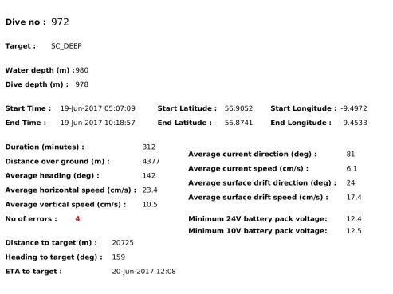
- Check data:  - Check time-series plots look ok (no patches of odd-looking colour)  - Check profile plots for all active sensors look ok (not too many spikes or large shifts from previous dives) | 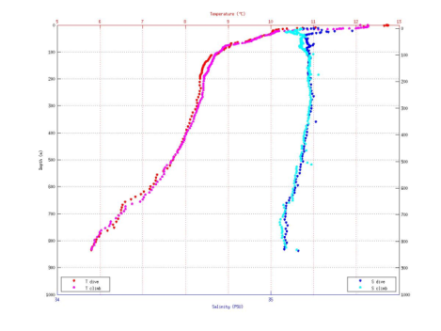
- Check depth:  - Look at altimeter bathy map and / or altimeter pings in log file  - Check altimeter detection results on diagnostic plot (caution: plot is a beta version and is still being tested. Do not trust 100% the suggested parameter changes on the bottom right, if these look strange notify glider manager).  - If the glider is hitting the bottom, getting false detections or is heading towards a shallow area adjust altimeter settings. | 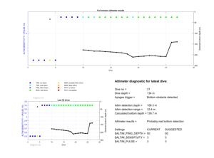  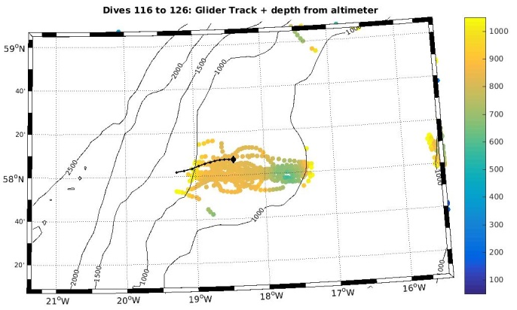
- Check glider DAC plots  - If the glider is likely to get stuck in a strong current that would cause a major detour re-route or change navigation mode | 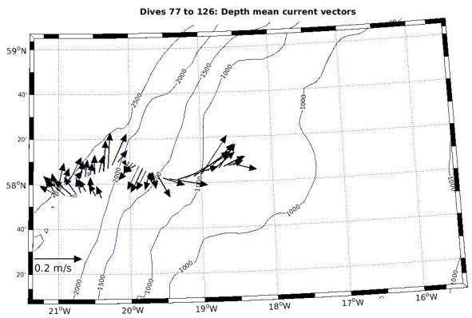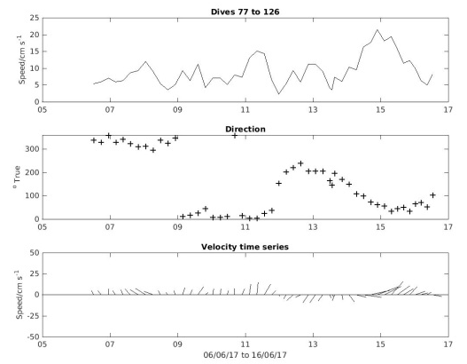
- Check glider flight:  Look at summary plot. Check that:  - Dive and climb angle and speeds are roughly symmetrical (symmetrical V shape of the height plot = solid red line)  - Speeds are reasonable (v = solid dark blue line, should be ~10cm/s)  - Glider going roughly in a straight line (heading = red dotted line)  - Glider not hitting the bottom (red, dark blue and cyan lines going flat at apogee)  - Glider not rolling too much on the same side for no obvious reason (roll = yellow solid line) | 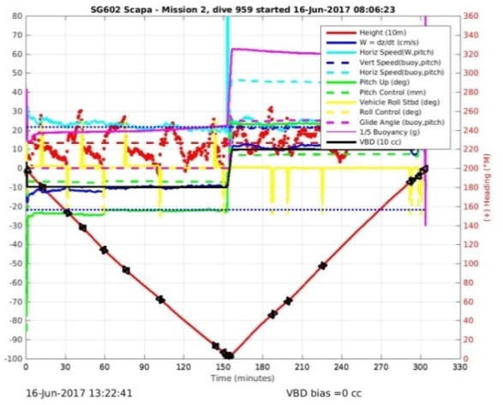
- Check motors A/D rates. On all subplots the readings (stars) should be above the set minimum values (red/orange dotted lines). | 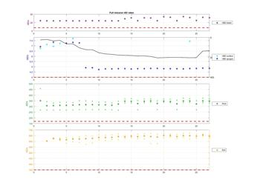
- Check safety parameters:  Check there are no sudden increases or changes in:  - Battery voltage = $24V_AH, $10V_AH (1st value)  - Energy usage = $24V_AH, $10V_AH (2nd value)  - $HUMID  - $INTERNAL_PRESSURE  - $ERRORS* | 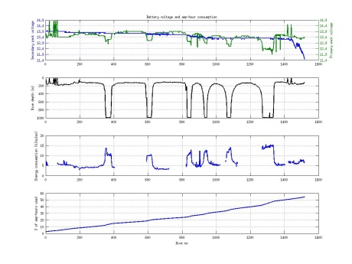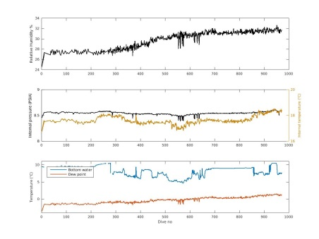
- Check ERRORS:  - GPS timeout: fairly common depending on glider code version. Can be ignored if it stays at 1.  - Spurious interrupts: should be at 0 most of the time, occasional 1 is normal.  - Roll retries: occasional retries are acceptable. If the retries become consistent or the number increases inform glider manager.  - Pitch retries: unusual, can be serious.  Inform glider manager asap.  - VBD retries: unusual, can be serious.  Inform glider manager asap.  - All other errors: unusual, inform glider manager. | 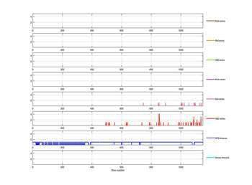  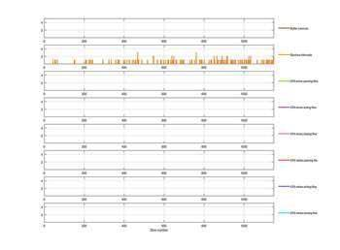

During working hours, and once per week-end

These are more thorough checks, which include all the steps above plus the extra ones below.
It is during those checks that the finder adjustments are made to the glider in terms of flight trimming, energy efficiency, data sampling, navigation planning, etc.

- Check map: as above +
changes to targets file if required
- Check data: as above +
changes to science file if required
- Check depth: as above
- Check currents: as above +
Route planning: have a look at eddy field / currents and establish if the glider might need re-routing in order to avoid a strong detour. Adjust targets file or $NAV_MODE if necessary. If the glider needs speeding up reduce $T_DIVE and / or increase $MAX_BUOY and review trimming after a few dives.
- Check glider flight: as above +
  - Look at summary plot. Check that:
    - Dive and climb angle and speeds are roughly symmetrical (symmetrical V shape of the height plot = solid red line)
    - Speeds are reasonable (v = solid dark blue line, should be ~10cm/s)
    - Glider going roughly in a straight line (heading = red dotted line)
    - Glider not hitting the bottom (red, dark blue and cyan lines going flat at apogee)
    - Glider not rolling too much on the same side for no obvious reason (roll = yellow solid line)
    - Glider not too heavy or too light check vertical velocities are similar and that the amount of oil bled and pumped is similar. Adjust $MAX_BUOY or $C_VBD if necessary.
  - Look at pitch regression plot:
    - Adjust $C_PITCH if necessary
  - Look at roll regression plot
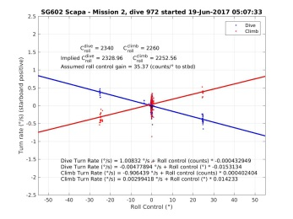
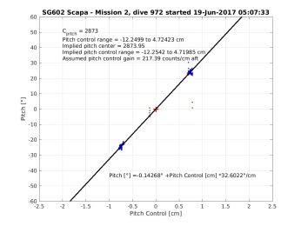
    - Adjust $C_ROLL_DIVE and $C_ROLL_CLIMB if necessary
- Check safety parameters: as above +
Use the check-up tool for a more thorough overview of basic parameters and a few others. To use it run the following command:
~/check_up_sg_nd.csh GGG NN
where GGG = glider serial number and NN = number of dives to check
- Energy efficiency check
  - Check energy usage is stable.
  - If the glider had to be sped up is it possible to reduce the speed now in order to save energy? Adjust $T_DIVE and / or $MAX_BUOY.
  - Check number of calls per surfacing. If the glider often needs more than one call increase $SM_CC. If there is only one call every time you can try reducing $SM_CC.
- Resend any missing dive data (using the command resend_dive in pdoscmds.bat file)

Emergency situation (RECOV alert)

When on call, the pilot should be able to reach a computer within 3 hours of receiving an emergency alert from a glider. If you know it is likely to take you a while to get to a computer then adjust call rate accordingly before leaving.

The alerts will come via email and text message (if set in pagers file). The message will be brief (especially in the text message) and you will probably need to look into the data files to understand why the abort was triggered. The glider will stay at the surface until it is commanded to start diving again.

Steps for responding to an alert message:
- Log onto basestation.
- Disable text alerts in .pagers file.
- Increase call rate ($T_RSLEEP) while you carry out debugging.
- Assess why the glider has gone into recovery.
  - The first clue will be in the alert message received, e.g.:
dive:6 calls_made:1 call_cycle:5 5742.7050 -1846.6650 05/21/17 20:30:51 UTC QUIT_COMMAND
Alternatively, you can also see it in the first line the glider writes in the comm.log after connecting:
6:1:1:0:6:262:0:109:2015:1757:-82.2:1.65:10.71:26.24:8.70:34.0 GPS,210517,201003,5742.543,-1846.585,17,1.0,17,-12.8,0.0,0.0,8,20.9
EOP_CODE=CONTROL_FINISHED_OK
RECOV_CODE=QUIT_COMMAND
ver=66.12,rev=CLOWNFISH,frag=4,launch=210517:112748
Iridium bars: 5 geolocation: 5720.523,-1849.049,210517,200334
Sometimes the recovery code will be enough to understand what’s happened (e.g. QUIT_COMMAND, or N_DIVES COMPLETED), or they might be fairly cryptic and require further investigation in the datafiles.
  - If the glider hasn’t uploaded the capture file automatically ask to send it (in pdoscmds.bat file: resend_dive /c NNN)
  - Look for critical lines in cap file. These will have the string “,C,” in them (do a search in browser / text editor, or do a grep in Putty terminal).
  - Have a look at the plots (especially the full summary one) to see if you can spot anything unusual.
  - Once you have established which device / parameter / behaviour triggered the abort have a look in the relevant section of the manuals.
  - Have a look in the pilot logs (on the website or in previous missions text logs under /home/pilot/pilot_logs) to see if the problem has happened before and if the logs give any explanation or clues on how to fix it.
- Even if the problem / error seems fairly straight-forward do a full check of glider to ensure there is no other underlying problems (safety parameters, flight behaviour, etc).
- If you have established what the problem is, and are 100% satisfied that you have fixed it and that the glider is ok you can make the glider carry on its mission (put a $RESUME in cmdfile, and switch to a $GO once it’s picked it up). If you are in any doubt do not send the glider diving and contact the glider manager.

