Radio Connection to Glider
- Plug radio to field computer
- Open TeraTerm
- Select Serial (see Device manager in computer for port number)
- Put the ON plug to the Glider
- Press q before the software starts, you have 10s (if it starts type $quit)
You are in the prompt to modify the configuration files or to go in test mode
To avoid watch dog (every 7 min) when in prompt type wd or to go in test mode
To go in test mode type runTester

Ethernet Cable Connection to Glider
- Connect with the Radio
- Type eth 0 followed by eth 1 onto the prompt
- If connecting to the payload, type pdl1 0 followed by pdl1 1 onto the prompt
- Go in test mode to avoid watch dog while connected with the cable
- Plug the Ethernet cable to the Glider, make sure you are connected to the wanted outlet (NAV/PLD)
- Open TeraTerm (for compass calibration) or Filezilla (load data)
- Select ssh connexion
Host 192.168.13.227
Username: user
Password: (none)

Opening the Glider at the Front
- Put the glider on bench frame with a piece of wood under middle-front
- Unscrew the split screws
- Unscrew pressor inlet
- You can put plastic film over O-rings to protect from dust and hair.
- Unplug 4 wires attached to the payload section (see picture below, red circle to unplug, green circle already free). These wires are altimeter, water inlet sensor, FLBBCD and ground.
- Do what you need to do before closing
- Clean and grease O-ring
- To reassemble the payload section on the yellow skull, put the skull vertically on the floor and with another person insert slowly the board and internal weight section in it while being careful not to scratch the part were the O-ring goes.
- Re-plug the 4 wires
- Check ground connexion from an anode to the other
- Clean and grease the O-rings
- Put all glider section together
- Connect to the glider with radio and go in test mode
- Vacuum to a pressure of 78000-80000
- Put the split screw back on by pushing not screwing (split aligned with glider circumference up-down like wanted to take a bit of the glider)
- Check vacuum again
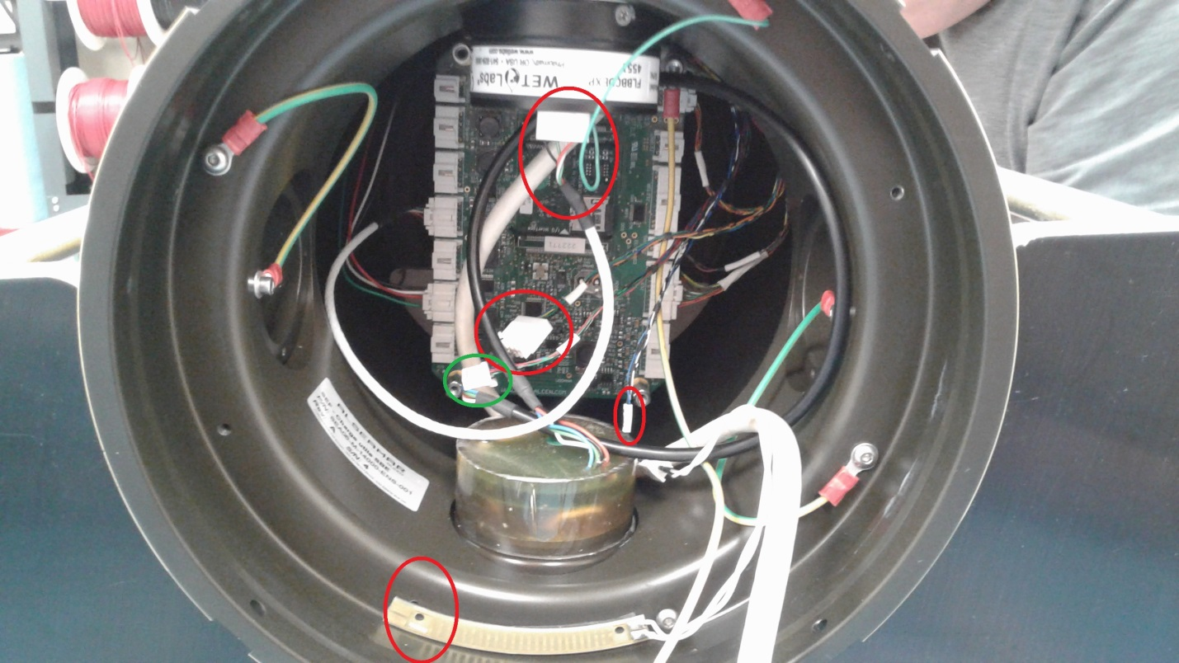
Ballasting
- Remove tube with sponge on the Ox sensor and plug proper tubing
- Remove the foams and weights if applicable
- Make sure everything is on the glider (fins, Argos tag, front and back caps, drop weight)
- Open the ballasting spreadsheet
- Weight the glider in air on the scale (cell F21)
- Put the targeted surface density in cell F27
- Stir pool, put CTD in tank, put pool density in cell F28
- Connect with the radio and go in test mode
- Check the vacuum
- Put the actuators to neutral position (linear at 50, angular at 0 and ballast at 0)
- Put the glider in water
- Remove air bubble in the CTD with a syringe, and remove bubble on altimeter
- Read the 2 scales and write it in cells E32 and F32 (if no reading move linear)
- Add foam or weight to make the weight of the glider at sea close to 0 (+/- 50g is fine) Note that with thermal compression the glider gets 4g heavier for every degree Celsius. Example: room T is 24 and water outside is 2, should ballast with a result 88g too light.
- Write the weight in air of foam in D32 and number of washer in C32
- Adjust the linear to make the two reads on the scale close to each other (no more than 58) write in cell L32
- Check the roll by changing the angular +45 -45 (expect reading between 11 and 13) write it in cells M32 and N32
- Lift the Glider and rinse it well
- Put the glider back on its cart
- OFF plug (if not doing a simulation just after)
- Put the tubing with sponge back around the Ox sensor if not deployed in the next few days
- Attach foams and washers to glider

Compass Calibration
- Bring with you to the compass hut: Ethernet cable, radio set, ON plug, computer (charged), drop weight, compass, Allen keys to remove fins
- Once at the hub, remove cell phone, magnetic card, keys, wallet, …
- Connect with the Radio
- Type eth 0 followed by eth 1 on the prompt
- Go in test mode
- Put the linear actuator to the ballasted value, the angular to 0 and the ballast to 0
- Connect with Ethernet cable to the Nav outlet (ssh connexion on TeraTerm)
- Cut the radio connection by typing radio 0
- Write compass 1
- Write compass2 –r /dev/ttyS2
- You’ll see reading with: Date Time Heading Pitch Roll
- Pitch and roll should be less than 1 degree
- Write down in spread sheet the 4 cardinal points (true or magnetic.. it’s just to compare with after calibration)
- Ctrl c to stop the readings
- Write compass 1
- Write compass2 –c /dev/ttyS2
- Follow what is written on screen (See drawing to know the roll direction)
- Press space when the step is done
- When it’s all over, type s to save in /root/calib.txt
- Put roll back to 0.
- Write down in spread sheet the 4 cardinal points after calibration to validate the calibration was okay
- OFF plug

Simulation
- Connect with the radio
- Make sure mode=1 in sea.cfg and that mission # was increased in sea.msn
- Go in test mode
- Check all the parameters and actuators (c v l a b e g f r d)
- Write runMission and let the 10s pass
- If you want to test Argos tag as well, plug wire to the tag, open the tagAgent software, go to Advance and check battery many times, go to Disconnect tag and select start
- Make sure Iris is in Manual Mode
- Put the glider outside, wait for Iridium communication (12 good, 3 not good)
- On radio connexion or on Iris, type $halt=0; when connected to Iridium (you should see waiting for go if it took the command)
- Go to properties to check the boxes to get the data files after every dive and to send $go automatically and uncheck halt=1; box
- Put in Iris mode
- Make 5 dives
- Check Argos location on website https://argos-system.clsamerica.com/argos-cwi2/login.html
- Type $quit; on radio connexion when the 5 dives are done
- Stop the Argos Tag with TagAgent software, go to Disconnect tag and select stop
Loading raw (delayed) data
- Connect with radio
- Type in prompt eth 0 followed by eth 1, pld1 0 followed by pld1 1
- Go in test mode
- Plug the Ethernet cable to the glider.
- Open Filezilla
Host nav:192.168.13.227 Username: user Password: none
- Make new mission directory in dropbox with subforlder nav and pld
- Copy/paste the folder logs and configs on the field computer
- Check depth, battery voltage, alarms on nav files, science data on pld files
- Make sure msn.lin.base is the right value in sea.msn and add one to mission number for deployment
- Change the mode for 0 in sea.cfg

To do before a deployment
- Charge glider, CTD, GoPro, Mifi, Computer, cell phone
- Put end of mission date on sticker
- Make sure ballasted foams and washers are attached to glider
- Clean and grease plugs
- Put several layers of coat on scratches
- Prep lat long in Piloting software ModuleWP
- Remove sponge, Fill GPCTD with salt water in winter (or air if SEA032)
- Put nose on
Equipment to bring onboard
- Field computer + power supply
- Radio set + On plug
- Drop weight + spring (at least 3)
- 25g washer (a lot)
- Foam (at least 2)
- Ethernet cable
- Glider + 2 covers + fins
- Plywood sheet for boat ramp
- Zipties (a lot and different size)
- Duct tape
- Electric tape
- Buoy + safety line
- Bridle system
- Magnet
- Argos cable (just in case)
- Allen keys + Screwdriver
- Side cutter
- Spare plastic screws
- Piloting manuals
- Phone + power supply
- Boat hook + rope
- CTD
- GoPro
- Sat phone
- Mifi
- Cart (if recovery)
- Turn on Argos Tag, same as for simulation
Deployment
10 min before getting to station:
- Setup computer with power supply
- Connect with the radio
- Turn on the glider by plugging the ON plug
- Make sure msn.lin.base is the right value in sea.msn
- Make sure msn.id is the right mission number in sea.msn
- Make sure mode is 0 in sea.cfg
- Go in test mode
- Check vacuum, Battery and Release system
- Connect to server
- Put Iris in Manual mode
On station:
- Put CDT in water to check surface density (adjust ballasting with weight and foam if needed)
- Prep glider (unfold antenna, make sure all plugs are there, put 2 caps on, check lock sleeve, Attached buoy with very long bowline)
- Type RunMission
- When connected to Iridium, check zb is 30 and alt is 20 in SEANAV sentence
- Turn on Argos Tag with magnet, expect 10 small dots ∙ ∙ ∙ ∙ ∙ ∙ ∙ ∙ ∙ ∙
- Check Iris connection one more time
- If there is a land pilot, ask permission to land pilot to deploy the glider
- Put glider in water
- Put drop weight at last minute
- Check position in water
- Ask permission to land to do the first 30 m dive
- You or land type $halt=0; (waiting for go) followed by $go;

After first dive
- Type $halt=1; (waiting for resume)
- Download the nav and date files (or ask land to do so)
- Plot data
- Check data, especially depth symmetry and pitch, should be around +/-20°
- Adjust $pu and $pd mm if needed (see drawing)

- Remove buoy
- Go for a second 30m dive $halt=0; (waiting for go) followed by $go;
- Do same steps than after first dive
- Check data, especially vertical speed, should be around +/- 15 cm/s
- Adjust $bu and $bd ml if needed (see drawing)

- Send glider on mission with ModuleWP
- Check heading commande sent
- Leave glider to land pilot
- Turn off radio (radio=0;), set altimeter to 15 m, set drift correction to 25%, send 2 last data files

During Mission
Send Ottawa the template of the MetaData to send real-time data to the GTS
- Check glider every 12h (battery, path, vacuum, pitch, vertical velocity, depth, surfacing rate)
- Check weather forecast
- Log the adjustments made on Glip
- If an alarm strike, make sure to understand what causes it before clearing it..
- If missing data files, can go in manual mode to load them

Recovery
- Before last surfacing, put in IRIS mode and go in properties to check the automatic $halt=1; box
- When recovering, remove drop weight first
- Put on deck
- Turn off the glider by replacing the ON plug by the OFF plug
- Turn off Argos Tag with magnet. Expect 3x2 dots ∙ ∙ ∙ ∙ ∙ ∙

On land
- Rinse it well
- Use triton to wash CTD, rinse and then use bleach solution 1:50. Let sit for 10 min and rinse a lot
- Put the tube with sponge back on Ox sensor
- Turn off permanently the Argos Tag by plugging the wire to it, open tagAgent software and using the magnet, go to Disconnect tag and select stop
- Load the delayed data files by connecting with Radio and then Ethernet cable as for after simulation
- Recharge the glider if needed by plugging in glider first and then in wall
- Process delayed mode data in SOCIB

